Green Thumb

a web app for Lawn Service companies



Project Plan

Trimpin, Sattar, Woolman

CMSC495 Current Trends

University of Maryland, University College

March 23,2019

**Table of Contents**

1. Overview 4

1.1 Project Summary 4

1.1.1 Purpose, Scope, and Objectives 4

1.1.2 Assumption and Constraints 5

1.2 Project Deliverables 5

1.3 Requirements 7

1.3.1 Required Features 7

1.3.2 Product Functions 7

1.3.3 Out-of-Scope Functionality 8

2. References 8

3. Definitions 8

4. Project Organization 9

4.1 External Organization 9

4.2 Internal Organization 9

4.3 Roles and Responsibilities 11

5. Project Managerial Process Plan 12

5.1 Development Schedule and Work Allocation 12

5.2 Version Control 14

6. Project Technical Process Plan 14

6.1 Development Model 14

6.2 Methods, Tools, and Techniques 14

7. Project Change Log 15

Addendums 18

Addendum A: Architectural Context Diagram (ACD) 18

Addendum B: Entity Relational Diagram (ERD) 19

Addendum C: Site Plan 20

Addendum D: Wireframe (Change the wireframe removing services, landscaping, and employee login and add Service and Products, 21

# 1. Overview

The software development plan will provide an overview of the requirements, breadth, schedule, and tasks for building and deploying the Green Thumb Lawn Service System (GTLSS) application. This software project document will provide a description of the project assumptions, required resources, and deliverables schedule.

## 1.1 Project Summary

### 1.1.1 Purpose, Scope, and Objectives

The main goal of the GTLSS suite is to provide businesses with a customer-facing web application that supports purchasing of lawn supplies and services as well as the administration of the business-related database. The software package will provide a customized pricing of services and products, inventory management, and storing of transaction records for services and products rendered.

Utilizing agile development practices, the scope of the project will be on developing an E-commerce website aligned with the GTLSS goal. Aspects outside the scope of the development plan include: admin portal (management of the business-related database), calendar feature (scheduling of services), employee and equipment scheduling, confirmation of employee and equipment availability, employee login capabilities, features for customers to specify non-allotted times for service, web hosting, secure VPN, authorization of payments, and synchronization of online and point of sale systems.

The objective of the GTLSS is to promote efficient use of resources for the business by allowing customers to order their lawn services electronically rather than over the phone or in person. The results for the business should be increased revenue and reduced expense costs. The software package should also help to improve customer satisfaction by eliminating the need for personal consultations, while enabling customers to easily browse and purchase landscaping supplies/services.

The product for delivery should include:

1. Software package consisting of:
   1. E-commerce Website
      * Services and Products (Purchase)
      * Landscaping Tips
      * About Us
      * Contact Page
      * Cart
      * Checkout
      * Confirmation
   2. Database with the following tables:
      * Category
      * Products (for Products and Services)
      * Customer
      * CustomerOrders
      * OrderedProduct
2. User guide

A successful implementation of the new E-commerce website for GTLSS will be determined by satisfaction of both the client and the customer base on usability and efficiency.

### 1.1.2 Assumption and Constraints

For the implementation of the web-based software package, the client will be held responsible for web hosting for the site, database hosting and management, secure VPN services, and hardware such as desktops or laptops to access applications within the software. Due to time constraints, the implementation will not provide admin portal (management of the business-related database), calendar feature (scheduling of services), employee login, validation of employee and equipment availability, optimization of routing systems to improve efficiency, features for customers to specify non-allotted times for service, nor provide functionality for equipment management due to servicing.

Some assumptions for the GTLSS includes: clients will have unlimited access to the software package; the site will run in HTML, CSS, JSP, Java Servlet, MySQL, and JavaScript, which should be supported across most operating systems and browsers. For the development process, free and open-source software (FOSS) will be used to accelerate time to develop and reduce overhead costs. Database software within the package will require detailed testing to ensure the relational database management systems (RDMS) can integrate with the web application.

Interfaces with other software and required acquisitions of software (FOSS-driven) are not applicable for the GTLSS software package.

## 1.2 Project Deliverables

The Project deliverables for the GTLSS will be focused on the following:

1. Software package consisting of:
   1. E-commerce Website (6 Pages of content)
      1. Services and Products (Purchase)
         1. Mowing (Categorized by size of lot small, medium, large)
         2. Tree Trimming (Categorized by number of trees small, medium, large)
         3. Shrub Trimming (Categorized by number small, medium, large)
         4. Plants
            * Perennials (Packages of 2, 4, 8)
            * Annuals (Packages of 8, 12 ,16
            * Vegetables (Packages of 2 & 4)
2. Mulch
3. Fertilizer
4. Soil
   * 1. Landscaping Tips
        1. Best times for planting, fertilization, mowing schedule, tree trimming, fertilization, etc.
     2. About Us
        1. Company Bio
        2. Honored employees
        3. Community Service
     3. Contact Page
        1. Customer form
        2. Text box for comments and questions (Emailed to Customer Support)
     4. Cart
        1. Itemized list of services and products requested including name, price
        2. Clear Cart
        3. Images of services and products
        4. Continue Shopping
        5. Proceed to Checkout
        6. Subtotal
     5. Checkout
        1. Customer billing details
        2. Purchase calculations
     6. Confirmation
        1. Order Summary
        2. Customer Details
   1. Database with the following tables:
      1. Category
      2. Products (for Products and Services)
      3. Customer
      4. CustomerOrders
      5. OrderedProduct

The software package of GTLSS will be a web-based application executed in HTML, CSS, JavaScript on the client-side and Java, JSP, and SQL on the server-side, which will allow the application to be hosted across most browsers and devices. The software package user guide will be provided via download.

## 1.3 Requirements

The GTLSS package will provide a web-based E-commerce website.

### 1.3.1 Required Features

* GTLSS provides the GUI that will include a Home page with the navigation bar (for accessing Service and Product Page, Landscaping tips, Contact page, Shopping cart widget etc.).
* Based on the selected navigation option, the user will see relevant information on the GUI displayed (currently available services/supplies, landscaping tips, checkout info and form, etc.).
* Services and Products page will allow customer input for selecting services and supplies. Customers will also be able to input supply quantity. This page will have "Add to Cart" button. Clicking "Add to Cart" button will place the service/supply order into the shopping cart.
* Landscaping Tips and About Us pages will represent just informative features by displaying landscaping tips and information about the Ecommerce lawn services company, respectively.
* Contact page will provide customers with the option to write a comment or question and email then to Customer Support of the Ecommerce lawn service company.
* When the customer is ready to purchase the service/supply in their cart, they can navigate to the Cart page where they will be allowed to see the details of the order, and enter customer billing information (name, address, credit card information, etc.). The Cart Page will have "Submit Order" button. Clicking "Submit Order" button will finalize the purchase, update the quantity of services/supplies in the database, and store customer data and order details in the database.
* Customer will be able to confirm ordered services and supplies on the Cart Page and remove services and supplies if they decided against purchasing them.
* The website will be processing payments for services and inventory.

### 1.3.2 Product Functions

Product functionality can be decomposed into the following areas:

* Service and Product Order Entry
* Comment Page - for emailing to Customer Service
* Tips and About Us information Displaying
* Order Removal
* Customer Billing Information Entry
* Payment Processing

Additional information regarding the functional decomposition or requirements can be found in Addendum A (Entity Relational Diagram) and Addendum B (Data Flow Diagram).

### 1.3.3 Out-of-Scope Functionality

* Secure Login for customer
* Confirmation of employee and equipment availability
* Employee and equipment scheduling
* Employee login capabilities
* Features for customers to specify non-allotted times for service
* Payment authorization
* Routing system for employees
* Calendar feature (scheduling of Service date by customer)
* Admin Portal (management of the business-related database)

# 2. References

The GTLSS project management plan consists of the following documents:

1. Software Development Plan and Software Requirements Specification
2. Software Design Document
3. Software Testing Specifications and User Guide
4. Final Documentation of the GTLSS Software

# 3. Definitions

The following definitions and lexicons will be referenced within the GTLSS design and development plan.

1. GTLSS – Green Thumb Lawn Service Software
2. GitHub – Web-based hosting service with version control for file/source code management
3. Agile - A lean development methodology used to describe and manage the process and workflow of a project on an iterative basis.
4. Slack – Team communication platform for discussion of documentation and coding of GTLSS.

# 4. Project Organization

The following sections will provide the project team organization to produce the GTLSS software package both internal and external. The project’s external organization will define the interfaces required to implement the software by businesses. The project’s internal organization will define members, roles and responsibilities.

## 4.1 External Organization

The external organization required will come from the web-based platform obtained for the implementation and purchasing of the software. The external organization will not be directly involved in development. Other external interfaces will be dealing with potential users for developing functionality i.e. business owners.

## 4.2 Internal Organization

The internal organization will consist of three (3) team members: Michelle Trimpin, Juhi Sattar, and Kristina Woolman. The GTLSS development team structure will utilize the skill set of all three (3) team members for HTML/CSS/JavaScript/Java Servlet/SQL development, and documentation and testing (see Figure 1).

**Figure 1. GTLSS Development Team Structure and Process Flow**

As Figure 1 indicates, the project will require input from all three members of the project team to successful implement the GTLSS software package. As the diagram indicates all team members will be directly related to the Project Plan, Architecture, Development, and Documentation due to the scale and deadline of the project. The Project Team will communicate on daily basis to provide initial input into the Project Plan and Architecture of the software package.

As the project moves to the development cycle, each member will utilize the GitHub repository to share source code and documentation. Developers will ensure the following requirements are met for change management and version control to ensure quality assurance across the software line:

1. Source code is committed to the Git repository on scheduled dates.
2. Source code provided should be sufficiently tested.
3. Source code provided to the Git repository will have comments and documentation.

As the development cycle moves to completion, team members will test the software to ensure design functionality adheres to the scope of the project plan. Each member will provide analysis of the testing phase for the purpose of completing documentation.

## 4.3 Roles and Responsibilities

Work roles and responsibilities that are essential for successful completion of the GTLSS project are presented in Table 1. Taking in consideration the limited number of project personnel, each team member will be responsible for multiple roles in order to complete the project on time.

**Table 1**

**Matrix of Work Roles and Responsibilities**

|  |  |  |
| --- | --- | --- |
| **Role** | **Description** | **Member Name** |
| Project Manager | Responsible for updating the project plan weekly along with maintaining a count on defects and issues. Responsible for feedback from the customer base. Responsible for contacting the client (professor) about any updates/issues that occur throughout the project. | Juhi Sattar |
| Team Leader | Responsible for leading the group, and directing the individual activity. Ensuring deadlines and deliverables are met. Organizes team chats and team-client/professor communications. Provide on-time deliverables to professor at periodic milestones within the project lifecycle. | Kristina Woolman |
| Quality Assurance Manager | Responsible for writing user guides and testing plan. Executes and documents testing results. Provides support to the developers in order to help troubleshoot issues on code/database if they arise. | Michelle Trimpin  Kristina Woolman |
| Developer | Responsible for writing the source code for the project to run. In charge of making sure the HTML/CSS/JavaScript/Java Servlet/SQL code runs smoothly as well as database and database connections. Designs the web app interface and front-end code, as well as ensures integration of the front-end and back-end code. | Kristina Woolman  Juhi Sattar  Michelle Trimpin |
| Technical Writer | Responsible for writing documentation supporting the project | Kristina Woolman  Juhi Sattar  Michelle Trimpin |

# 5. Project Managerial Process Plan

The project managerial process plan emphasizes the project schedule and task milestones that have been outlined for each week and are needed to keep the team on focus and to meet the agreed upon project goals.

## 5.1 Development Schedule and Work Allocation

The GTLSS team will consist of the following team members:

* Michelle Trimpin
* Juhi Sattar
* Kristina Woolman

The Project Plan illustrated below in the Timeline chart along with a formal description of milestones will provide the client with scheduling of the development cycle. See timeline inserted below.

|  |  |  |  |  |  |  |  |
| --- | --- | --- | --- | --- | --- | --- | --- |
| **Project Timeline for Green Thumb Lawn Service Software** | | | | | | | |
| **Weeks** | | | | | | | |
| 3/24-3/29 | 3/30-4/4 | 4/5-4/9 | 4/10-4/15 | 4/16-4/21 | 4/22-4/28 | 4/29-5/4 | 5/4-5/11 |
| **Project Plan and Requirements**    **Code build for Skeleton Website**    **Design Plan**  **Build for Database**  **Test Plan and User Guide**  **Code Site pages**    **Functionality of Database**    **Code Functionality for Website**    **Testing**  **Final Write Up**   |  |  |  |  |  | | --- | --- | --- | --- | --- | | **Project Description** | **Task**  **Lead** | **Start Date** | **End Date** | **Notes** | | Project Start | All | 3/24 | 3/24 | Kick-off for project | | Create Project Plan and Requirements Specification | Juhi Sattar | 3/25 | 3/29 | Creation of Project Plan with input from Team Members Michelle Trimpin, and Kristina Woolman. | | Project Design | Juhi Sattar | 3/30 | 4/5 | Creation of Project Design Plan with input from Team Members Michelle Trimpin, Juhi Sattar, and Kristina Woolman. | | Test Plan and User Guide | Kristina Woolman | 4/5 | 4/14 | Creation of Project Plan with input from Team Members Michelle Trimpin, and Kristina Woolman. | | Architecture build of site in HTML/CSS/JavaScript/JSP | Juhi Sattar | 3/28 | 4/3 | Build the skeleton framework of the site map including the layout, nav bar, footer, Index, and Cart (checkout, confirmation) pages. | | Architecture build of Database in SQL | Kristina Woolman | 3/28 | 4/20 | Build the Framework of the database for product, category, customer, ordered_product, customer_order. | | Build site pages | Kristina Woolman | 4/7 | 4/19 | Build the site page for the Services and Products, Landscaping Tips, and Confirmation. | | Build site pages | Michelle Trimpin | 4/7 | 4/19 | Build site pages for the About Us and Contact pages. | | Build functionality for databases | Kristina Woolman | 4/16 | 4/30 | Provide features for server-side updates to database with input from Team Members: Michelle Trimpin, and Kristina Woolman | | Build functionality for checkout and scheduling | Juhi Sattar | 4/17 | 5/5 | Provide functionality for checkout, payment, and confirmation with input from Team Members: Michelle Trimpin, and Kristina Woolman | | Testing | Michelle Trimpin | 4/30 | 5/7 | Testing through User Cases developed by Team Members Team Members Michelle Trimpin, Juhi Sattar, and Kristina Woolman. | | Final Write up of GTLSS Build | Juhi Sattar | 5/7 | 5/12 | Creation of document for final write-up Team Members Michelle Trimpin, Juhi Sattar, and Kristina Woolman. | | Project End | All | 5/12 | 5/12 | Submission of the final project deliverables | | | | | | | | |

The development of GTLSS will have no budgetary constraints. The only constraint facing the development of GTLSS will resource allocation and time.

## 5.2 Version Control

Version control for all source code within the GTLSS suite development cycle will be handled through GitHub. Documentation and software code will be available at the GitHub repository for review and assessment on reaching key milestones.

The URL to the project repository is: <https://github.com/green-thumbs>.

# 6. Project Technical Process Plan

This section covers the development model being used for this project as well as the tools, techniques, and methods chosen to be utilized during this software development. The development environment utilizes the Netbeans IDE, MYSQL, and GlassFish server.

## 6.1 Development Model

The development model to be used by the project team is an Agile model. The utilization of this model allows for flexible development of the software while maintaining an achievable set timeline for other tasks within the project.

## 6.2 Methods, Tools, and Techniques

In order to provide for a uniform standard across the project team the following tools will be utilized during project development:

1. Integrated Development Environment - NetBeans IDE 8.2 All bundle
2. Language – HTML/CSS/JavaScript/SQL/Java
3. Platform – JDK 8.0 or newer
4. Servlet and Java Server Pages (JSP) Technologies
5. Enterprise JavaBeans (EJB) Technology
6. Java Persistence API (JPA)
7. Java Server Pages Standard library (JTSL)
8. Java Database connectivity (JDBC)
9. Internet connection (LAN, Wi-Fi).
10. Third-party web browser (Firefox, Chrome, Edge)
11. Server (GlassFish Server)
12. SQL server for database (MySQL)
13. Code repository – GitHub
14. Communication channel - Slack
15. Documentation – Microsoft Office 2013 or newer
16. Chart and mockup development - Lucidchart and Gliffy

JDK 8.0 or newer will be used in order to utilize the up to date features of the language. NetBeans IDE 8.2 All bundle will be used for the software source code development (older versions or other bundles may not support all features necessary for e-commerce website development). GitHub will serve as the main repository for both version control and accessibility of source code and documentation. A Slack workspace will be set up to support collaboration between all team members. Using project management tools such as Slack and GitHub will allow team members to coordinate our efforts in documenting, coding, and tracking weekly goals and deliverables. All documentation will be done in Microsoft Office 2013 or newer.

# 7. Project Change Log

|  |  |  |  |  |
| --- | --- | --- | --- | --- |
| Project Change Log for GTLSS | | | | |
| ID | Change Description | Document Changed | Date Revision | Comments |
| 001-P | Number of Site Pages | Project Plan | 04/15/2019 | Consolidated Services and Landscaping supplies pages into one new Services and Products page. |
| 002-P | Number of Services and Products offered | Project Plan | 04/15/2019 | Reduced offered items from Services and Products. |
| 003-P | Renamed Checkout page | Project Plan | 04/15/2019 | Changed name of Checkout page to Cart page. |
| 004-P | Removal of Team Member | Project Plan | 04/15/2019 | Removed Paul Davison from: Internal Organizational chart on page 10,  Table 1: Matrix of work roles and Responsibilities on page 11-12, and  5.1 Development Schedule and work allocation spreadsheet on page 13. |
| 005-P | Additional tools and methods added to 6.2 Methods, tools, and Techniques on page 15-16 | Project Plan | 04/15/2019 | Added more tools and methods:   * Servlet and Java Server Pages (JSP) Technologies * Enterprise JavaBeans (EJB) Technology * Java Persistence API (JPA) * Java Server Pages Standard library (JTSL) * Java Database connectivity (JDBC) |
| 006-P | Change of diagram for Site Plan | Project Plan | 04/15/2019 | Addendum C: Site Plan - Converted Services page and Landscaping Supplies page to Services and Product page; renamed Checkout page to Cart page. (page 18) |
| 007-P | Removal of the Admin Login page | Project Plan | 04/25/2019 | Removed Admin Login from Project Scope, Deliverables, Required Features, Required Functions, and Project Timeline, and Addendum C. |
| 008-P | Addition of Admin Login to Out-scope Functionality | Project Plan | 04/25/2019 | Added Admin Login to Out-Scope Functionality section 1.3.3. |
| 009-P | Removal of Calendar Scheduling feature | Project Plan | 04/25/2019 | Removed Calendar Scheduling feature from Project Scope, Deliverables, Required Features, Required Functions, Project Timeline, Database deliverable, and Addendum A and C. |
| 010-P | Addition of Calendar Scheduling to Out-Scope Functionality | Project Plan | 04/25/2019 | Added Calendar feature to Out-Scope Functionality section 1.3.3. |
| 011-P | Addition of Cart and Confirmation pages | Project Plan | 04/25/2019 | Added Cart and Confirmation pages to Project Deliverables. Added Cart to Addendum A. |
| 012-P | Removal of DBMS Entities | Project Plan | 04/25/2019 | Removed from DBMS the following Entities : calendar management, services, employees, equipment, customer accounts, customer billing, ProdOrderDetails, ServOrderDetails, and inventory management. Removed from Addendum B and C. |
| 013-P | Addition of DBMS Entities | Project Plan | 04/25/2019 | Added to the DBMS the following Entities: product, category, customer_order, ordered_product, and customer. Added to Addendum B and C. |

# Addendums

## Addendum A: Architectural Context Diagram (ACD)

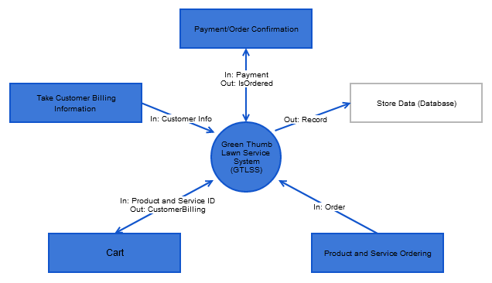

## Addendum B: Entity Relational Diagram (ERD)

## 

## Addendum C: Site Plan

## 

## Addendum D: Wireframe (Change the wireframe removing services, landscaping, and employee login and add Service and Products,

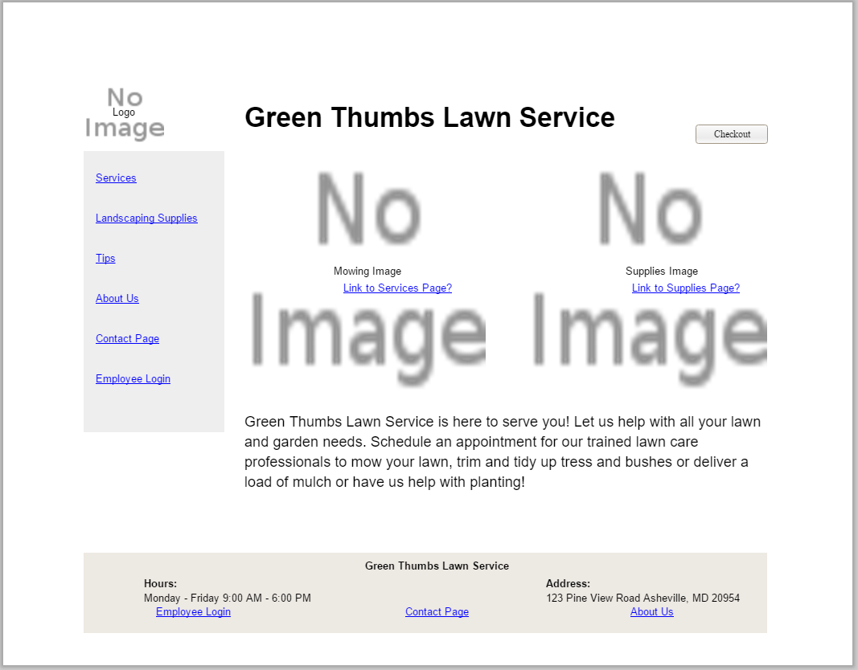

(Michelle)